University Physics with Modern Physics, 14e, Global Edition (Young/Freedman)
Chapter 1 Units, Physical Quantities, and Vectors

1.1 Conceptual Questions

1) The current definition of the standard meter of length is based on
A) the distance between the earth's equator and north pole.
B) the distance between the earth and the sun.
C) the distance traveled by light in a vacuum.
D) the length of a particular object kept in France.
Answer: C
Var: 1

2) The current definition of the standard second of time is based on
A) the frequency of radiation emitted by cesium atoms.
B) the earth's rotation rate.
C) the duration of one year.
D) the oscillation of a particular pendulum kept in France.
Answer: A
Var: 1

3) The current definition of the standard kilogram of mass is based on
A) the mass of the earth.
B) the mass of the sun.
C) the mass a particular object kept in France.
D) the mass of a cesium-133 atom.
Answer: C
Var: 1

4) If a woman weighs 125 lb, her mass expressed in kilograms is x kg, where x is
A) less than 125.
B) greater than 125.
Answer: A
Var: 1

5) If a tree is 15 m tall, its height expressed in feet is x ft, where x is
A) less than 15.
B) greater than 15.
Answer: B
Var: 1
6) If a flower is 6.5 cm wide, its width expressed in millimeters is x mm, where x is
A) less than 6.5.
B) greater than 6.5.
Answer: B
Var: 1

7) If an operatic aria lasts for 5.75 min, its length expressed in seconds is x s, where x is
A) less than 5.75.
B) greater than 5.75.
Answer: B
Var: 1

8) Scientists use the metric system chiefly because it is more accurate than the English system.
A) True
B) False
Answer: B
Var: 1

9) When adding two numbers, the number of significant figures in the sum is equal to the number of significant figures in the least accurate of the numbers being added.
A) True
B) False
Answer: B
Var: 1

10) When determining the number of significant figures in a number, zeroes to the left of the decimal point are never counted.
A) True
B) False
Answer: B
Var: 1
11) Which of the following is an accurate statement?
A) The magnitude of a vector can be zero even though one of its components is not zero.
B) It is possible to add a scalar quantity to a vector.
C) Even though two vectors have unequal magnitudes, it is possible that their vector sum is zero.
D) Rotating a vector about an axis passing through the tip of the vector does not change the vector.
E) The magnitude of a vector is independent of the coordinate system used.
Answer: E
Var: 1

12) If 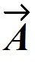 - 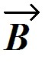 = 0, then the vectors and have equal magnitudes and are directed in the opposite directions from each other.
A) True
B) False
Answer: B
Var: 1

13) Under what condition is | - | = A + B?
A) The magnitude of vector is zero.
B) Vectors and are in opposite directions.
C) Vectors and are in the same direction.
D) Vectors and are in perpendicular directions.
E) The statement is never true.
Answer: B
Var: 1

14) If A > B, under what condition is | - | = A - B?
A) The statement is never true.
B) Vectors and are in opposite directions.
C) Vectors and are in the same direction.
D) Vectors and re in perpendicular directions.
E) The statement is always true.
Answer: C
Var: 1
15) For the vectors shown in the figure, express vector 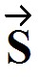 in terms of vectors 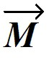 and 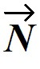.
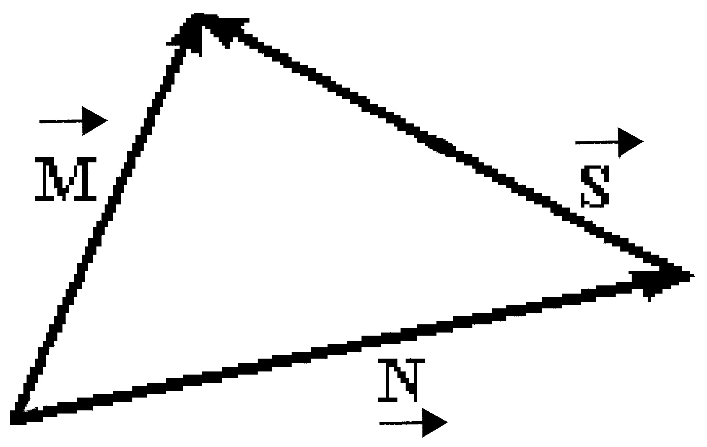

Answer: 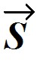 = - 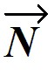
Var: 1

16) The magnitude of a vector can never be less than the magnitude of one of its components.
A) True
B) False
Answer: A
Var: 1

17) If the magnitude of vector is less than the magnitude of vector , then the x component of is less than the x component of .
A) True
B) False
Answer: B
Var: 1

18) If the eastward component of vector is equal to the westward component of vector and their northward components are equal. Which one of the following statements about these two vectors is correct?
A) Vector is parallel to vector .
B) Vectors and point in opposite directions.
C) Vector is perpendicular to vector .
D) The magnitude of vector is equal to the magnitude of vector .
E) The magnitude of vector is twice the magnitude of vector .
Answer: D
Var: 1
19) If all the components of a vector are equal to 1, then that vector is a unit vector.
A) True
B) False
Answer: B
Var: 1

20) If the dot product of two nonzero vectors is zero, the vectors must be perpendicular to each other.
A) True
B) False
Answer: A
Var: 1

21) If two nonzero vectors point in the same direction, their dot product must be zero.
A) True
B) False
Answer: B
Var: 1

22) The value of the dot product of two vectors depends on the particular coordinate system being used.
A) True
B) False
Answer: B
Var: 1

23) If two vectors are perpendicular to each other, their cross product must be zero.
A) True
B) False
Answer: B
Var: 1

24) If two vectors point in opposite directions, their cross product must be zero.
A) True
B) False
Answer: A
Var: 1
25) If and are nonzero vectors for which ∙ = 0, it must follow that
A) × = 0.
B) is parallel to .
C) | × | = AB.
D) | × | = 1.
Answer: C
Var: 1

1.2 Problems

1) Convert 1.2 × 10-3 to decimal notation.
A) 1.200
B) 0.1200
C) 0.0120
D) 0.0012
E) 0.00012
Answer: D
Var: 5

2) Write out the number 7.35 × 10-5 in full with a decimal point and correct number of zeros.
A) 0.00000735
B) 0.0000735
C) 0.000735
D) 0.00735
E) 0.0735
Answer: B
Var: 5

3) 0.0001776 can also be expressed as
A) 1.776 × 10-3.
B) 1.776 × 10-4.
C) 17.72 × 104.
D) 1772 × 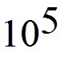.
E) 177.2 × 107.
Answer: B
Var: 5
4) 0.00325 × 10-8 cm can also be expressed in mm as
A) 3.25 × 10-12 mm.
B) 3.25 × 10-11 mm.
C) 3.25 × 10-10 mm.
D) 3.25 × 10-9 mm.
E) 3.25 × 10-8 mm.
Answer: C
Var: 1

5) If, in a parallel universe, π has the value 3.14149, express π in that universe to four significant figures.
A) 3.141
B) 3.142
C) 3.1415
D) 3.1414
Answer: A
Var: 1

6) The number 0.003010 has
A) 7 significant figures.
B) 6 significant figures.
C) 4 significant figures.
D) 2 significant figures.
Answer: C
Var: 1

7) What is 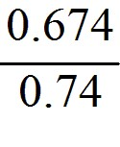 to the proper number of significant figures?
A) 0.91
B) 0.911
C) 0.9108
D) 0.9
Answer: A
Var: 50+
8) What is the value of π(8.104)2, written with the correct number of significant figures?
A) 206.324
B) 206.323
C) 206.3
D) 206
E) 200
Answer: C
Var: 1

9) What is the sum of 1123 and 10.3 written with the correct number of significant figures?
A) 1.13 × 103
B) 1133.3000
C) 1.1 × 103
D) 1133.3
E) 1133
Answer: E
Var: 1

10) What is the sum of 1.53 + 2.786 + 3.3 written with the correct number of significant figures?
A) 8
B) 7.6
C) 7.62
D) 7.616
E) 7.6160
Answer: B
Var: 3

11) What is the difference between 103.5 and 102.24 written with the correct number of significant figures?
A) 1
B) 1.3
C) 1.26
D) 1.260
E) 1.2600
Answer: B
Var: 3
12) What is the product of 11.24 and 1.95 written with the correct number of significant figures?
A) 22
B) 21.9
C) 21.92
D) 21.918
E) 21.9180
Answer: B
Var: 3

13) What is the result of 1.58 ÷ 3.793 written with the correct number of significant figures?
A) 4.1656 × 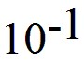
B) 4.166 ×
C) 4.17 ×
D) 4.2 ×
E) 4 ×
Answer: C
Var: 3

14) What is 34 + (3) × (1.2465) written with the correct number of significant figures?
A) 37.7
B) 37.74
C) 4 × 101
D) 38
E) 37.7395
Answer: D
Var: 5

15) What is 56 + (32.00)/(1.2465 + 3.45) written with the correct number of significant figures?
A) 62.8
B) 62.812
C) 62.81
D) 63
E) 62.8123846
Answer: D
Var: 1
16) Add 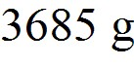 and 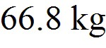 and express your answer in milligrams (mg).
A) 7.05 × 107 mg
B) 7.05 × 104 mg
C) 7.05 × 105 mg
D) 7.05 × 106 mg
Answer: A
Var: 50+

17) Express (4.3 × 106)-1/2 in scientific notation.
A) 4.8 × 10-4
B) 2.1 × 103
C) 2.1 × 10-5
D) 2.1 × 104
Answer: A
Var: 40

18) What is 0.2052/3, expressed to the proper number of significant figures?
A) 0.348
B) 0.35
C) 0.3
D) 0.3477
Answer: A
Var: 50+

19) The length and width of a rectangle are 1.125 m and 0.606 m, respectively. Multiplying, your calculator gives the product as 0.68175. Rounding properly to the correct number of significant figures, the area should be written as
A) 0.7 m2.
B) 0.68 m2.
C) 0.682 m2.
D) 0.6818 m2.
E) 0.68175 m2.
Answer: C
Var: 1
20) The following exact conversion equivalents are given: 1 m = 100 cm, 1 in = 2.54 cm, and 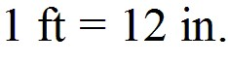 If a computer screen has an area of 1.27 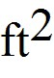, this area is closest to
A) 0.00284 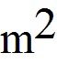.
B) 0.0465 .
C) 0.118 .
D) 0.284 .
E) 4.65 .
Answer: C
Var: 1

21) In addition to 1 m = 39.37 in., the following exact conversion equivalents are given: 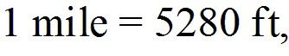 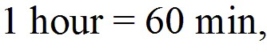 and 1 min = 60 s. If a particle has a velocity of 8.4 miles per hour, its velocity, in m/s, is closest to
A) 3.8 m/s.
B) 3.0 m/s.
C) 3.4 m/s.
D) 4.1 m/s.
E) 4.5 m/s.
Answer: A
Var: 50+

22) A weight lifter can bench press 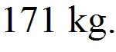 How many milligrams (mg) is this?
A) 1.71 × 108 mg
B) 1.71 × 109 mg
C) 1.71 × 107 mg
D) 1.71 × 106 mg
Answer: A
Var: 50+

23) How many nanoseconds does it take for a computer to perform one calculation if it performs 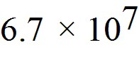 calculations per second?
A) 15 ns
B) 67 ns
C) 11 ns
D) 65 ns
Answer: A
Var: 50+
24) The shortest wavelength of visible light is approximately 400 nm. Express this wavelength in centimeters.
A) 4 × 10-5 cm
B) 4 × 10-7 cm
C) 4 × 10-9 cm
D) 4 × 10-11 cm
E) 400 × 10-11 cm
Answer: A
Var: 1

25) The wavelength of a certain laser is 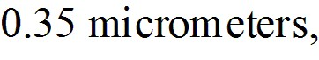 where 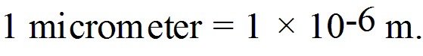 Express this wavelength in nanometers.
A) 3.5 × 102 nm
B) 3.5 × 103 nm
C) 3.5 × 101 nm
D) 3.5 × 104 nm
Answer: A
Var: 50+

26) A certain CD-ROM disk can store approximately 6.0 × 102 megabytes of information, where 106 bytes = 1 megabyte. If an average word requires 9.0 bytes of storage, how many words can be stored on one disk?
A) 6.7 × 107 words
B) 5.4 × 109 words
C) 2.1 × 107 words
D) 2.0 × 109 words
Answer: A
Var: 9

27) A plot of land contains 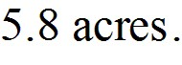 How many square meters does it contain? 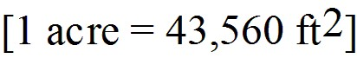
A) 2.3 × 104 m2
B) 7.1 × 103 m2
C) 7.0 × 104 m2
D) 5.0 × 104 m2
Answer: A
Var: 50+
28) A person on a diet loses 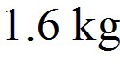 in a week. How many 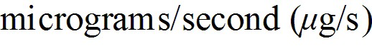 are lost?
A) 2.6 × 103 μg/s
B) 1.6 × 105 μg/s
C) 44 μg/s
D) 6.4 × 104 μg/s
Answer: A
Var: 11

29) Albert uses as his unit of length (for walking to visit his neighbors or plowing his fields) the albert (A), the distance Albert can throw a small rock. One albert is 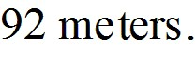 How many square alberts are equal to one acre? (1 acre = 43,560 ft2 = 4050 m2)
Answer: 1.29 A2
Var: 50+

30) Convert a speed of 4.50 km/h to units of ft/min. (1.00 m = 3.28 ft)
A) 0.246 ft/min
B) 82.3 ft/min
C) 165 ft/min
D) 246 ft/min
E) 886 ft/min
Answer: D
Var: 1

31) The exhaust fan on a typical kitchen stove pulls 600 CFM (cubic feet per minute) through the filter. Given that 1.00 in. = 2.54 cm, how many cubic meters per second does this fan pull?
A) 0.283 m3/sec
B) 0.328 m3/sec
C) 3.05 m3/sec
D) 32.8 m3/sec
Answer: A
Var: 1

32) The mass of a typical adult woman is closest to
A) 20 kg.
B) 35 kg.
C) 75 kg.
D) 150 kg.
Answer: C
Var: 1
33) The height of the ceiling in a typical home, apartment, or dorm room is closest to
A) 100 cm.
B) 200 cm.
C) 400 cm.
D) 500 cm.
Answer: B
Var: 1

34) Approximately how many times does an average human heart beat in a year?
A) 4 ×
B) 4 × 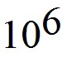
C) 4 × 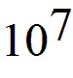
D) 4 × 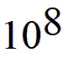
E) 4 × 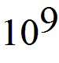
Answer: C
Var: 1

35) Approximately how many times does an average human heart beat in a lifetime?
A) 3 × 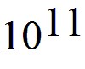
B) 3 × 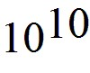
C) 3 ×
D) 3 ×
E) 3 ×
Answer: C
Var: 1

36) Approximately how many pennies would you have to stack to reach an average 8-foot ceiling?
A) 2 × 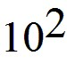
B) 2 × 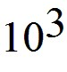
C) 2 × 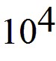
D) 2 ×
E) 2 ×
Answer: B
Var: 1
37) Estimate the number of times the earth will rotate on its axis during a human's lifetime.
A) 3 ×
B) 3 ×
C) 3 ×
D) 3 ×
E) 3 ×
Answer: A
Var: 1

38) Estimate the number of pennies that would fit in a box one foot long by one foot wide by one foot tall.
A) 5 ×
B) 5 ×
C) 5 ×
D) 5 ×
E) 5 ×
Answer: C
Var: 1

39) A marathon is 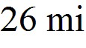 and 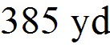 long. Estimate how many strides would be required to run a marathon. Assume a reasonable value for the average number of 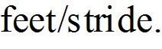
A) 4.5 × 104 strides
B) 4.5 × 103 strides
C) 4.5 × 105 strides
D) 4.5 × 106 strides
Answer: A
Var: 1
40) The period of a pendulum is the time it takes the pendulum to swing back and forth once. If the only dimensional quantities that the period depends on are the acceleration of gravity, g, and the length of the pendulum, ℓ, what combination of g and ℓ must the period be proportional to? (Acceleration has SI units of m • s-2.)
A) g/ℓ
B) gℓ2
C) gℓ
D) 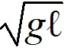
E) 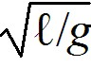
Answer: E
Var: 1

41) The speed of a wave pulse on a string depends on the tension, F, in the string and the mass per unit length, μ, of the string. Tension has SI units of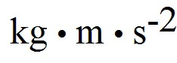 and the mass per unit length has SI units of 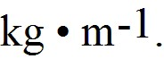 What combination of F and μ must the speed of the wave be proportional to?
A) F / μ
B) μ / F
C) 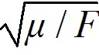
D) 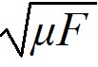
E) 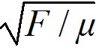
Answer: A
Var: 1

42) The position x, in meters, of an object is given by the equation x = A + Bt + Ct2, where t represents time in seconds. What are the SI units of A, B, and C?
A) m, m, m
B) m, s, s
C) m, s, s2
D) m, m/s, m/s2
E) m/s, m/s2, m/s3
Answer: A
Var: 1
43) You walk 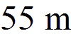 to the north, then turn 60° to your right and walk another 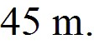 How far are you from where you originally started?
A) 87 m
B) 50 m
C) 94 m
D) 46 m
Answer: A
Var: 31

44) Vectors and 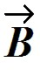 are shown in the figure. Vector 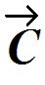 is given by = - . The magnitude of vector is 16.0 units, and the magnitude of vector is 7.00 units. What is the magnitude of vector ?
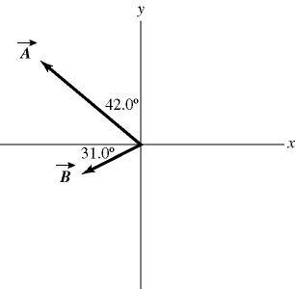
A) 9.00
B) 9.53
C) 15.5
D) 16.2
E) 17.5
Answer: D
Var: 1
45) Vectors and are shown in the figure. Vector is given by = - . The magnitude of vector is 16.0 units, and the magnitude of vector is 7.00 units. What is the angle of vector , measured counterclockwise from the +x-axis?
A) 16.9°
B) 22.4°
C) 73.1°
D) 287°
E) 292°
Answer: D
Var: 1

46) A rabbit trying to escape a fox runs north for 8.0 m, darts northwest for 1.0 m, then drops 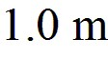 down a hole into its burrow. What is the magnitude of the net displacement of the rabbit?
A) 8.8 m
B) 8.1 m
C) 66 m
D) 10 m
Answer: A
Var: 50+
47) You walk 53 m to the north, then turn 60° to your right and walk another Determine the direction of your displacement vector. Express your answer as an angle relative to east.
A) 63° N of E
B) 50° N of E
C) 57° N of E
D) 69° N of E
Answer: A
Var: 50+

48) Vector has a magnitude 5.00 and points in a direction 40.0° clockwise from the negative y axis. What are the x and y components of vector .
A) Ax = 3.83 and Ay = 3.21
B) Ax = 3.83 and Ay = -3.21
C) Ax = -3.21 and Ay = -3.83
D) Ax = -3.21 and Ay = 3.83
E) Ax = 4.29 and Ay = 2.16
Answer: C
Var: 5

49) The components of vector are 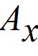 = + 3.90 and 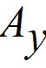 = -4.00. What is the angle measured counterclockwise from the +x-axis to vector ?
A) 314°
B) 134°
C) 224°
D) 136°
E) 46.0°
Answer: A
Var: 1
50) Vector 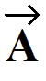 has a magnitude of 5.5 cm and points along the x-axis. Vector 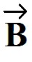 has a magnitude of 7.5 cm and points at +30° above the negative x-axis.
(a) Determine the x and y components of Vector .
(b) Determine the x and y components of Vector 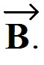
(c) Determine x and y components of the sum of these two vectors.
(d) Determine the magnitude and direction of the sum of these two vectors.
Answer:
(a) = 5.5 cm, = 0
(b) 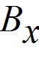 = -6.5 cm, 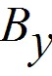 = 3.8 cm
(c) 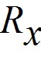 = -1.0 cm, 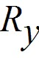 = 3.8 cm
(d) 3.9 cm at 75° above -x-axis
Var: 1

51) Vector has a magnitude of 75.0 cm and points at 30° above the positive x-axis. Vector has a magnitude of 25.0 cm and points along the negative x-axis. Vector 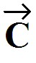 has a magnitude of 40.0 cm and points at 45° below the negative x-axis.
(a) Determine the x and y components of Vector .
(b) Determine the x and y components of Vector .
(c) Determine the x and y components of Vector .
(d) Determine x and y components of the sum of these three vectors.
(e) Determine the magnitude and direction of the sum of these three vectors.
Answer:
(a) = 65 cm, = 38 cm
(b) = -25 cm, = 0
(c) 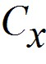 = -28 cm, 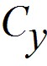 = -28 cm
(d) = 12 cm, = 9.2 cm
(e) 15 cm at 38° above +x-axis
Var: 1

52) A helicopter is flying horizontally with a speed of 444 m/s over a hill that slopes upward with a 2% grade (that is, the "rise" is 2% of the "run"). What is the component of the helicopter's velocity perpendicular to the sloping surface of the hill?
A) 8.9 m/s
B) 220 m/s
C) 435 m/s
D) 444 m/s
Answer: A
Var: 50+
53) An apple falls from an apple tree growing on a 20° slope. The apple hits the ground with an impact velocity of 16.2 m/s straight downward. What is the component of the apple's impact velocity parallel to the surface of the slope?
A) 5.5 m/s
B) 8.7 m/s
C) 12 m/s
D) 15 m/s
Answer: A
Var: 50+

54) The components of vector are = +2.2 and = -6.9, and the components of vector are given are = -6.1 and = -2.2. What is the magnitude of the vector - ?
A) 9.5
B) 6.1
C) 9.9
D) 91
E) 0.76
Answer: A
Var: 50+

55) The components of vector are = -3.5 and = -9.7, and the components of vector are = -6 and = +8.1. What is the angle (less than 180 degrees) between vectors and ?
A) 124°
B) 56°
C) 17°
D) 163°
E) 106°
Answer: A
Var: 50+
56) An airplane undergoes the following displacements: First, it flies 66 km in a direction 30° east of north. Next, it flies 49 km due south. Finally, it flies 100 km 30° north of west. Using vector components, determine how far the airplane ends up from its starting point.
A) 79 km
B) 81 km
C) 82 km
D) 78 km
E) 76 km
Answer: A
Var: 1

57) In the figure, the magnitude of vector is 18.0 units, and the magnitude of vector is 12.0 units. What vector must be added to the vectors and so that the resultant of these three vectors points in the -x direction and has a magnitude of 7.50 units? Use vector components to find your answer, and express vector by giving its magnitude and the angle it makes with the +x-axis taking counterclockwise to be positive.
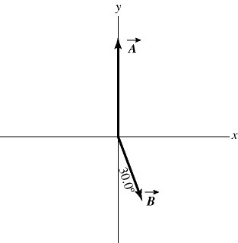
Answer: 15.5, 209°
Var: 1
58) Three forces are exerted on an object placed on a tilted floor. Forces are vectors. The three forces are directed as shown in the figure. If the forces have magnitudes 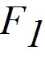 = 1.0 N, 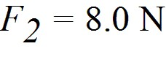 and 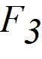 = 7.0 N, where N is the standard unit of force, what is the component of the net force 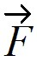net = 1 + 2 + 3 parallel to the floor?

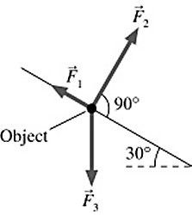
A) 2.5 N
B) 5.1 N
C) 6.0 N
D) 7.8 N
Answer: A
Var: 29
59) As shown in the figure, three force vectors act on an object. The magnitudes of the forces as shown in the figure are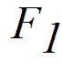 = 80.0 N, 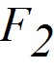 = 60.0 N, and = 40.0 N, where N is the standard SI unit of force. The resultant force acting on the object is given by
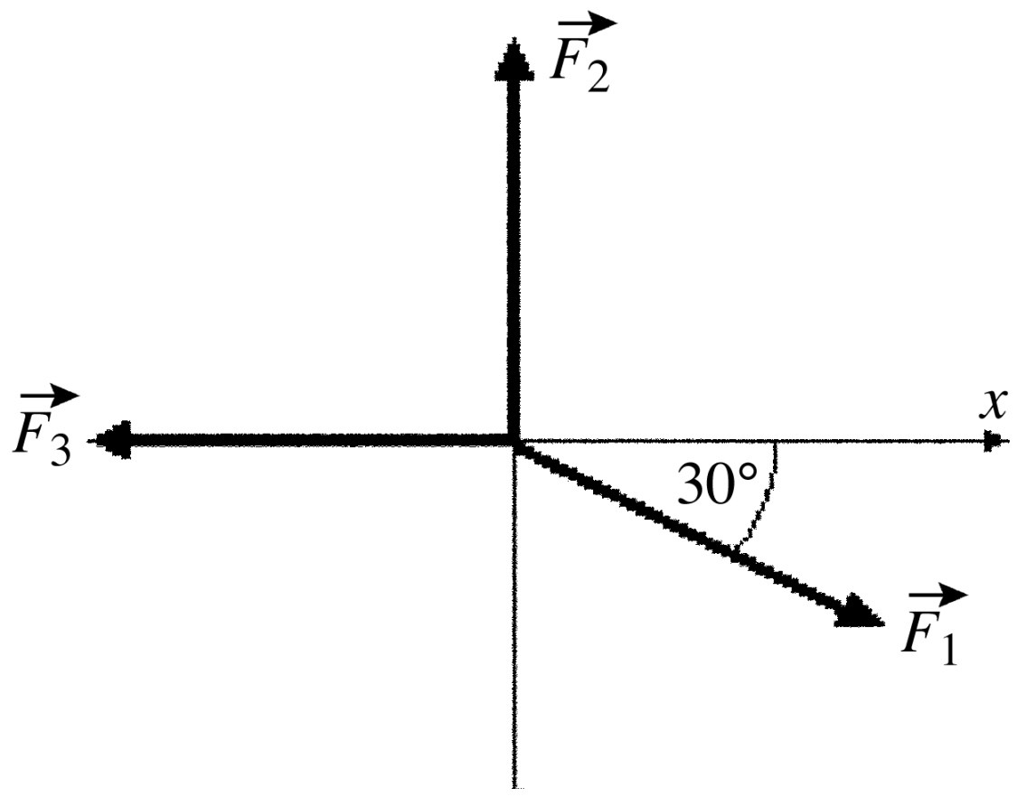
A) 180 N at an angle 60.0° with respect to +x-axis.
B) 60.0 N at an angle 90.0° with respect to +x-axis.
C) 20.0 N at an angle 34.3° with respect to +x-axis.
D) 35.5 N at an angle 34.3° with respect to +x-axis.
E) 40.0 N at an angle 60.0° with respect to +x-axis.
Answer: D
Var: 1

60) A teacher sends her students on a treasure hunt. She gives the following instructions:
1. Walk 300 m north.
2. Walk 400 m northwest.
3. Walk 700 m east-southeast and the treasure is buried there.
As all the other students walk off following the instructions, Jane physics student quickly adds the displacements and walks in a straight line to find the treasure. How far and in what direction does Jane need to walk?
A) 187 m in a direction 67.3° north of east
B) 481 m in a direction 40.9° north of east
C) 399 m in a direction 52.5° north of east
D) 284 m in a direction 28.2° west of north
E) The treasure position cannot be reached in one straight walk.
Answer: B
Var: 1
61) Vector = -3.00 + 3.00 and vector = 3.00 + 4.00 . What is vector = + ?
A) 0.00 + 3.00
B) 7.00 + 7.00
C) -3.00 + 7.00
D) 0.00 + 7.00
E) -3.00 - 3.00
Answer: D
Var: 1

62) Vector = 1.00 + -2.00 and vector = 3.00 + 4.00 . What are the magnitude and direction of vector = + ?
A) 7.21 in a direction 33.7° counterclockwise from the positive x axis
B) 6.00 in a direction 63.4° counterclockwise from the positive x axis
C) 4.47 in a direction 6.34° counterclockwise from the positive x axis
D) 4.47 in a direction 26.6° counterclockwise from the positive x axis
E) 7.21 in a direction 56.3° counterclockwise from the positive x axis
Answer: D
Var: 1

63) What is the magnitude of + + , where = 1.00 + 4.00 - 1.00 , 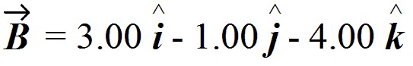and = -1.00 + 1.00 ?
A) 7.07
B) 2.00
C) 10.76
D) 6.78
E) 8.12
Answer: A
Var: 9
64) If = +4 - 2 - 3 and = -4 -2 - 3 , which of the following numbers is closest to the magnitude of - ?
A) 8
B) 7
C) 9
D) 10
E) 11
Answer: A
Var: 50+

65) Vector = -1.00 + -2.00 and vector = 3.00 + 4.00 . What are the magnitude and direction of vector = 3.00 + 2.00?
A) 3.61 in a direction -56.3° counterclockwise from the positive x-axis
B) 3.61 in a direction 56.3° counterclockwise from the positive x-axis
C) 3.61 in a direction 33.7° counterclockwise from the positive x-axis
D) 5.00 in a direction 56.3° counterclockwise from the positive x axis
E) 6.72 in a direction 34.4° counterclockwise from the positive x-axis
Answer: C
Var: 1
66) Vectors and are shown in the figure. What is 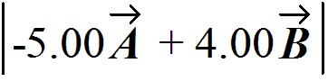?

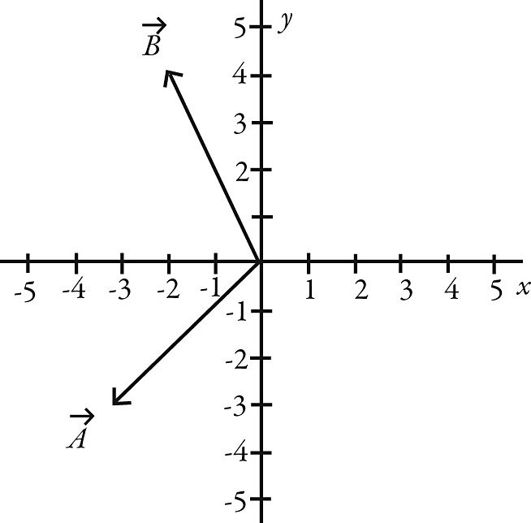
A) 31.8
B) -32.0 - 2.00
C) 1028
D) 34.0
E) -2.00 - 32.0
Answer: A
Var: 1

67) Determine the scalar product of = 6.0 + 4.0 - 2.0 and 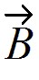 = 5.0 - 6.0 - 3.0.
A) 30 + 24 + 6
B) 30 - 24 + 6
C) 12
D) 60
E) undefined
Answer: C
Var: 5
68) Determine the angle between the directions of vector = 3.00 + 1.00 and vector
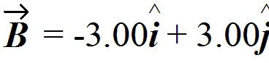.
A) 26.6°
B) 30.0°
C) 88.1°
D) 117°
E) 45.2°
Answer: D
Var: 5

69) The scalar product of vector = 3.00 + 2.00 and vector is 10.0. Which of the following vectors could be vector ?
A) 2.00 + 4.00
B) 4.00 + 6.00
C) 5.00 + 4.00
D) 12.0
E) 2.00 + 2.00
Answer: E
Var: 5

70) The angle between vector = 2.00 + 3.00 and vector is 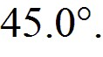 The scalar product of vectors and is 3.00. If the x component of vector is positive, what is vector .
A) 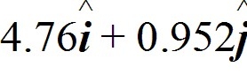
B) 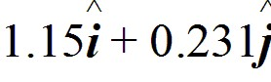
C) 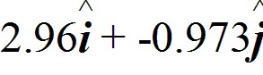
D) 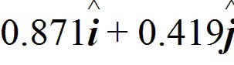
E) 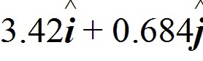
Answer: B
Var: 5
71) What is the angle between the vector = +3 - 2 - 3 and the +y-axis?
A) 115°
B) 65°
C) 25°
D) 155°
E) 90°
Answer: A
Var: 16

72) If = 3 - + 4 and = x + - 5, find x so will be perpendicular to .
Answer: 7
Var: 1

73) Two boys searching for buried treasure are standing underneath the same tree. One boy walks 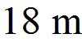 east and then north. The other boy walks 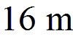 west and then 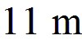 north. Find the scalar product of their net displacements from the tree.
Answer: -90
Var: 50+

74) A rectangular box is positioned with its vertices at the following points:
A = (0,0,0) C = (2,4,0) E = (0,0,3) G = (2,4,3)
B = (2,0,0) D = (0,4,0) F = (2,0,3) H = (0,4,3)
If the coordinates all have three significant figures, the angle between the line segments AG and AH is closest to:
A) 21.8°.
B) 22.5°.
C) 26.6°.
D) 36.9°.
E) 45.0°.
Answer: A
Var: 1
75) For the vectors shown in the figure, assume numbers are accurate to two significant figures. The scalar product × is closest to

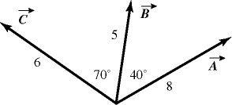

A) zero.
B) 16.
C) 45.
D) -16.
E) -45.
Answer: D
Var: 1

76) What is the vector product of = 2.00 + 3.00 + 1.00 and = 1.00 - 3.00 - 2.00 ?
A) -3.00 + 5.00 - 9.00
B) -5.00 + 2.00 - 6.00
C) -9.00 - 3.00 - 3.00
D) -4.00 + 3.00 - 1.00
E) 2.00 -9.00 - 2.00
Answer: A
Var: 1

77) What is the magnitude of the cross product of a vector of magnitude 2.00 m pointing east and a vector of magnitude 4.00 m pointing 30.0° west of north?
A) 6.93
B) -6.93
C) 4.00
D) -4.00
E) 8.00
Answer: A
Var: 1
78) If the magnitude of the cross product of two vectors is one-half the dot product of the same vectors, what is the angle between the two vectors?
Answer: 26.6°
Var: 1

79) If = -4 - 2 - 3, what is × ?
A) +3 - 4
B) +3 + 4
C) -3 + 4
D) +3 + 2 - 4
E) -3 - 2 + 4
Answer: A
Var: 50+

80) If = -2 - 6 + 2 and = -2 -2 - 3, which of the following numbers is closest to the magnitude of × ?
A) 25
B) 21
C) 17
D) 13
E) 9
Answer: A
Var: 50+
81) For the vectors shown in the figure, find the magnitude and direction of × , assuming that the quantities shown are accurate to two significant figures.

A) 26, directed into the plane
B) 26, directed out of the plane
C) 31, directed on the plane
D) 31, directed into the plane
E) 31, directed out of the plane
Answer: A
Var: 1

82) For the vectors shown in the figure, find the magnitude and direction of the vector product 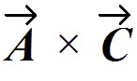, assuming that the quantities shown are accurate to two significant figure.

A) 16, directed into the plane
B) 16, directed out of the plane
C) 45, directed on the plane
D) 45, directed into the plane
E) 45, directed out of the plane
Answer: E
Var: 1

